***CS231 Assignment 2 Report***

**Introduction:**

This program is used to solve an 8-puzzle problem using Breadth-First Search (BFS) algorithm which finds the shortest distance to reach the final state of the puzzle from initial state. Some initial states reach final state whereas there are some initial states that do not reach final state (program keeps on running).

**Algorithm:**

Breadth-First Search (BFS) has been implemented in this program to reach the final state.

**Data Structure:**

Structures used in this program are as follow:

* Trees – Consists of root pointer and nodes which are connected to the root and thus form a tree. Nodes consists of matrixes which store the state of puzzle after moving blank tile (0) and it also stores the parent pointer which stores the address of parent node (It links nodes together).
* Queue – It is used to implement BFS algorithm. Nodes from the tree are added to the queue starting from the root node and they are removed from head (FIFO) to reach the final state.

**Program Execution:**

Initially, the user is asked to enter the initial state of the puzzle. The blank tile is considered as 0. The program executes and returns the path taken to reach the final state of the puzzle. However, the program keeps on running for some initial conditions and thus no output is returned. The reason for this which I believe is that it is unable to reach the final state because it continuously returns to the state which it has previously visited and thus it enters infinite loop (I haven’t tested the program for larger values of time and thus it is my assumption that it runs in infinite loop).

**Output:**

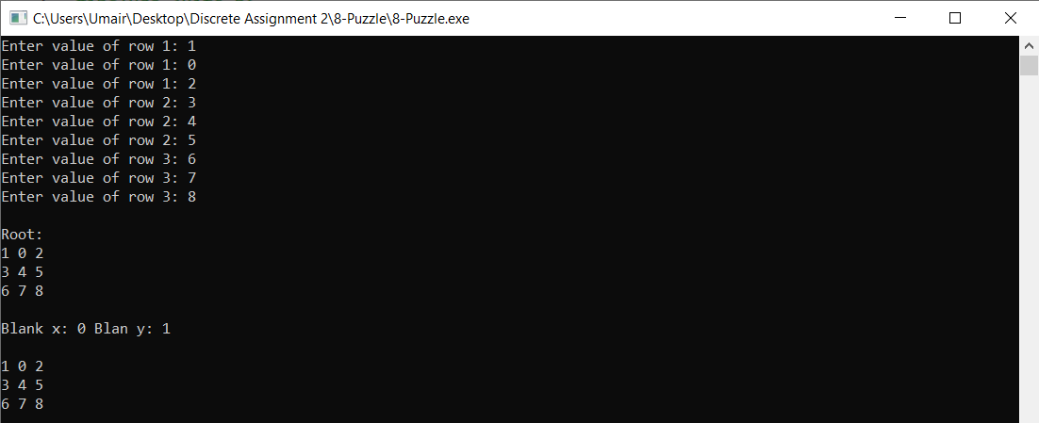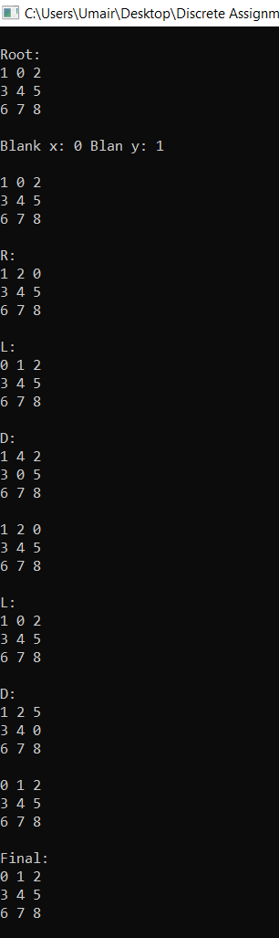The output shows the states of the puzzle starting from the initial condition till the final condition. It starts by showing the puzzle matrix stored in root pointer and then it displays the puzzle matrixes of all the child nodes (4 children at most namely: L, R, U, D) until the final state is reached. It then displays the final state.

